Based on the Jun and Dec precipitation data, from 50% and 75% level, most of the time for Jun and Dec, the precipitation has no much difference. Dec’s precipitation is a little bit higher than Jun and the max level are higher. Also, though 25% level has no precipitation, but 50% and 75% are all good. Not too much rain but enough rain to keep it green. From 50% and 75% temperature data, most of the time for Jun and Dec, the temperature has no much difference. The Dec temperature on average is lower than Jun. Max level is similar but the minimum level is lower for Dec. Looking at 25% to 75% temperature level, the temperature is comfortable and good for business. And the standard deviation is both small for Jun and Dec. So from the temperature perspective, it is suitable for business.

I have two recommendations. First, we can select the data from most active station. The data from most active station would be more reliable. Second, we can shorten the period to only last 3 to 5 years so that it is more similar to the future. As if the period is too extended, the weather change may be larger.

Jun precipitation and temperature

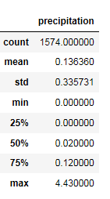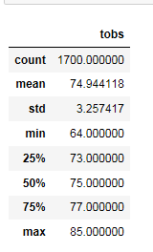

Dec precipitation and temperature

